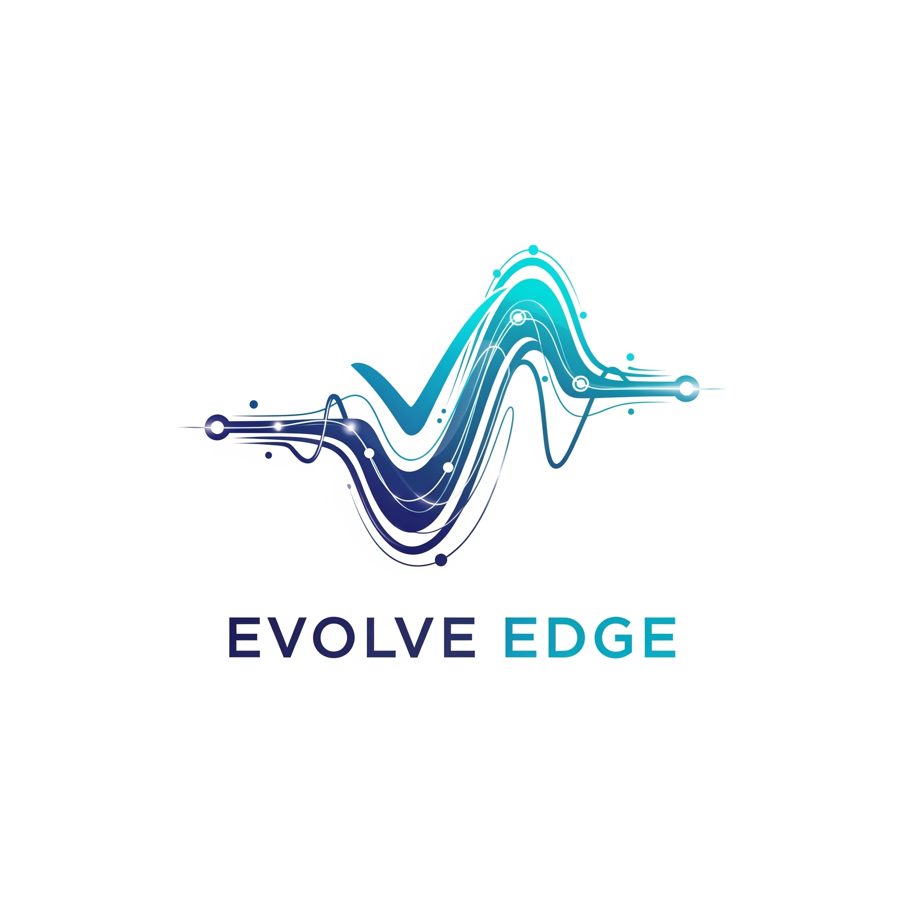

Company Overview & Vision
Evolve Edge is building an AI-powered compliance and cybersecurity automation platform for regulated companies that are underserved by today’s expensive, consultant-heavy compliance ecosystem. As regulatory pressure increases across fintech, healthcare, and SaaS, smaller teams are compelled to manage enterprise-grade requirements without access to enterprise resources. Evolve Edge’s vision is to become the foundational operating layer that enables continuous, automated, and affordable compliance from day one.
Problem
Compliance today is slow, manual, and costly. Early-stage and growing companies often rely on spreadsheets, point solutions, and external consultants to prepare for audits and manage risk. This approach drains capital, delays growth, and still leaves gaps that expose organizations to regulatory and security failures. Existing enterprise tools are overbuilt and overpriced for this segment, creating a clear opportunity for a lean, automation-first platform.
Solution
Evolve Edge delivers a centralized AI-driven platform that automates evidence collection, maps controls across multiple compliance frameworks, and continuously identifies risk gaps with clear remediation guidance. Instead of preparing for compliance reactively, customers gain an always-on system that reduces audit preparation from months to days while eliminating the majority of manual effort.
Business Model
The company operates a capital-efficient SaaS model with tiered monthly subscriptions starting in the low hundreds of dollars, designed to scale with customer maturity. As customers grow, they expand into higher tiers and add-on modules for additional frameworks, reporting, and integrations. This creates strong recurring revenue potential with clear expansion paths and attractive unit economics over time.
Early Validation & Market Signal
Initial customer discovery and market research show strong demand from regulated startups and SMBs seeking a simpler, more affordable alternative to consultant-led compliance. Buyers consistently validate the core value proposition: saving time, reducing cost, and gaining clarity in an otherwise complex regulatory environment. These early signals support a large, underserved market with urgent, non-discretionary needs.
Pre-Seed Raise & Use of Funds
Evolve Edge is raising $750,000 to $1,000,000 at the pre-seed stage to reach product-market validation milestones. Capital will be used to finalize core platform capabilities, onboard early customers, and establish repeatable go-to-market channels. The focus of this raise is speed, learning, and validation—not premature scaling.
Why Velocity Raise
Velocity Raise provides a structured and efficient pathway to connect with pre-seed accredited investors who understand early-stage SaaS risk and upside. Their investor access, outreach automation, and fundraising infrastructure align with our goal of raising capital efficiently while staying focused on product execution and customer discovery.
Investor Upside
Evolve Edge is targeting a large and growing compliance automation market with a product designed for early adoption and long-term expansion. Pre-seed investors gain early entry into a scalable SaaS platform addressing a mission-critical problem, with the potential to evolve into a category-defining compliance infrastructure company as regulatory complexity continues to increase.

